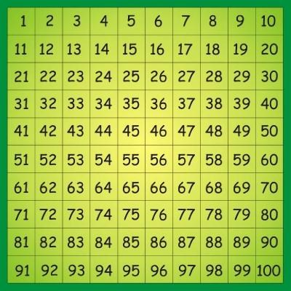
Addition
I can add 1 to a 2 digit number.
28 + 1 = 29
43 + 1 = 44
86 + 1 = 87

I can add 10 to a 2 digit tens number.
40 + 10 = 50

70 + 10 = 80

I can add 10 to any 2 digit number.
23 + 10 = 33
41 + 10 = 51

I can add a 1 digit number to a 2 digit tens number.

30 + 4 = 34

50 + 6 = 56

80 + 2 = 82

I can solve a 2 digit + a 1 digit number.

Tens = 30
Units = 2 + 4 = 6
Tens + Units = 30 + 6 = 36
I can add a 2 digit tens number to another one.

+
20

60
=

Start with the larger number.

60
+ 20 =
80

2 tens and 6 tens are 8 tens

So

20
+ 60 =
80

?

I can solve any 1 digit + 1 digit number in my head See learn its sheet

I can solve any 2 digit number + 1 digit number. 68 + 9 =

60 + 17 = 77

I can add any 2 digit tens number to another one.

80+ 90 8 tens add 9 tens 17 tens 17 tens are 170 80 + 90 = 170
I can add a 2 digit tens number to a 2 digit number.
I can add any 2 digit tens number to a 2 digit number 23 + 40 =
20 + 40 3 + 0
60 + 3 = 63

I can add a 2 digit number to a 2 digit number. 43 + 52 =

40 + 50 3 + 2
90 + 5 = 95
Subtraction
I can take 10 from a multiple of 10.
I can take 10 from a 2 digit number
40 – 10 = 30
80 – 10 = 70
43 – 10 = 33
76 – 10 = 66

I can take a multiple of 10 from a multiple of 10
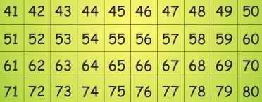

80

–

300
=
50

8
tens
–

3
tens = 5 tens

5
tens =
50

I can take a 1 digit number from a multiple of 10.

30 – 3 = 27
70 – 6 = 64

I can solve a 2 digit number – a 1 digit number.
48 - 5 = 43
___________________________________________
43 44 45 46 47 48

I can solve any 2 digit number – a 1 digit number.
43 – 7 = 36

___________________________________________

36

40

43

-
4

-
3

I can solve any 3 digit number – a 1 digit number.

343 – 7 =
-3

_____
______________________________________

-
4

336 340 343

Multiplication
I can draw out groups of dots.

I can find the total number of dots.

3 + 3 + 3 + 3
4 lots of 3 = 4 x 3 = 12

I can write out repeated addition. 5 x 3 = 3 + 3 + 3 + 3 + 3 = 15
I can solve repeated addition.

1 2 3 4 5 6 7 8 9 10 11 12 13 14 15

I can solve a 1 digit number x a 1 digit number.

3 x 5 =15 or 5 x 3 = 15

5 x 3 = 15
1 2 3 4 5 6 7 8 9 10 11 12 13 14 15

Division
I can share equally to solve division problems.
There are 6 sweets, how many people can have 2 sweets each?

I can make groups of 2, 5 or 10.

I can find how many altogether by counting through each group.
1, 2, 3, 4, 5 6, 7, 8, 9, 10
I can find how many altogether by counting in 2s, 5s or 10s.

5, 10, 15

I can arrange a division number sentence.
15 blocks going into piles of 3:

How many lots of 3 are there in 15?

I can solve a division number sentence with objects.
12 ÷ 3 = 4
3 3 3 3

1 2 3 4 5 6 7 8 9 10 11 12 13 14 15

I can solve division using objects (with remainders).

17 ÷ 3 = 5 r2 ____1____2_______3_____4_______5_______r2__________
0 1 2 3 4 5 6 7 8 9 10 11 12 13 14 15 16 17

I can use a tables fact to find a division fact.

If 6 x 4 = 24 then 24 ÷ 4 = 6

* Children to use their knowledge of the Learn Its to support them with this *

